IPv4 Routing
1. Routing using one Router
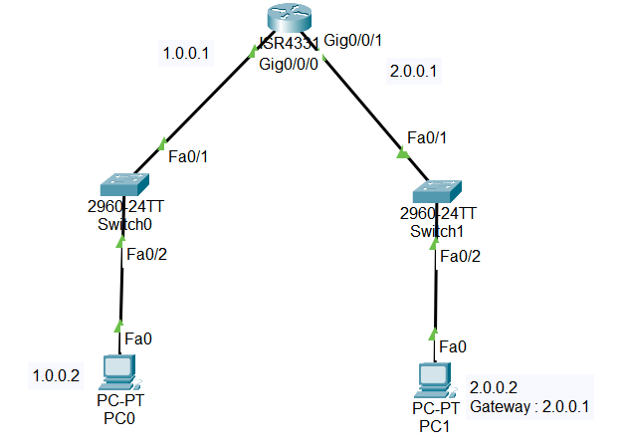
Components : 1 Switch ; 2 PC’s
Connect 2 PC’s with different network i.e 1.0.0.0 and 2.0.0.0
Then in the Router add them as a Routing to each other
In CLI of Router to configure interfaces
Router> en
Router#conf t
Enter configuration commands, one per line. End with CNTL/Z.
Router(config)#int g0/0/0
Router(config-if)#ip add 1.0.0.1 255.0.0.0
Router(config-if)#no shutdown

2. Routing using 2 Routers:
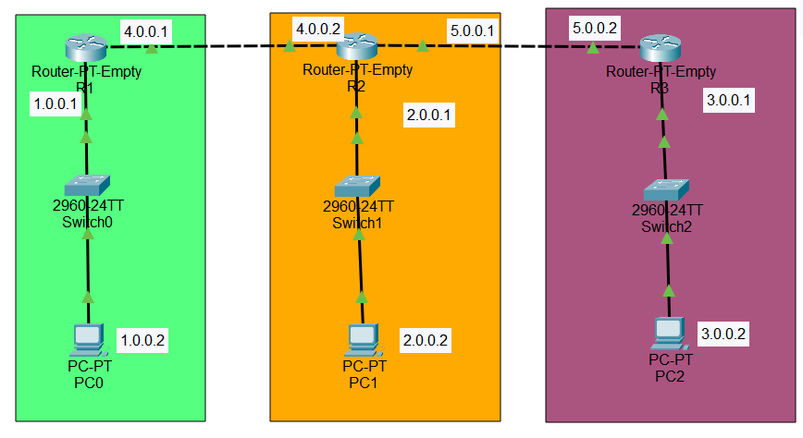
Components required: 2 Routers ; 4 PC’s ; 2 Switches
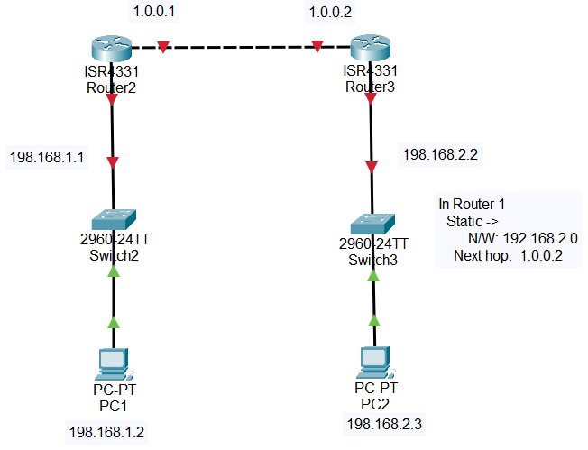
Since we have 2 Routers
we use 2 completely different Networks on both end and add them as hop to the routers to each other for connection.
3. Routing using 3 Routers :
Components required: 3 Routers ; 3 Switches ; PC’s
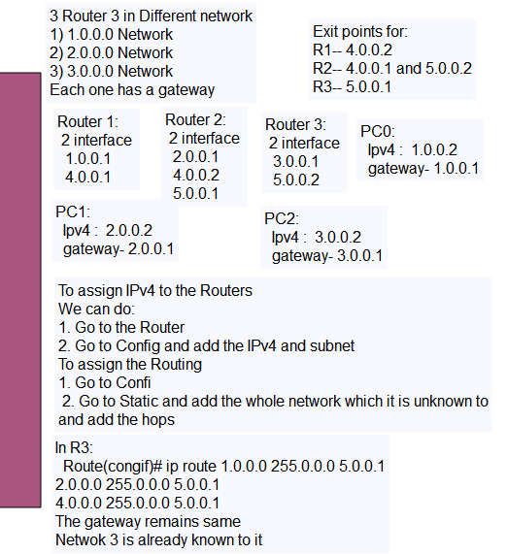
4. Dynamic Routing / Routing using 3 Router and 2 Switches:
Components required: 3 Routers; 2 Switches
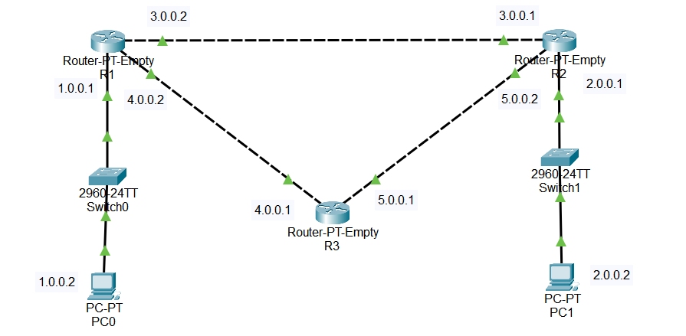
As we see all the connections are made with different Networks
We use Empty Routers and place a 1CGE slot to make sure the connections are made based on our need.
In CLI: IP route 0.0.0.0 0.0.0.0 exit point
Using Dynamic routing helps if a PC wants to commute to any device not in their Network they can use this exit point and commute to any device in any network.
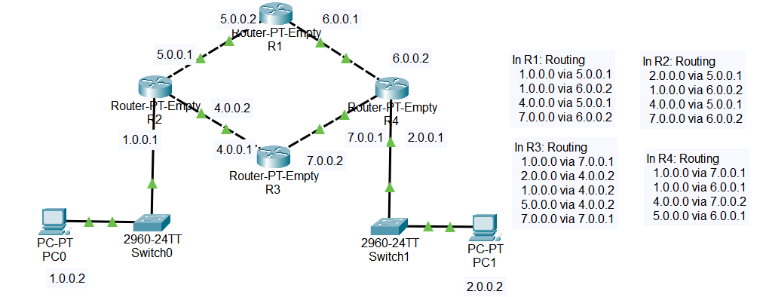
5. Routing using 4 Routers:

